Crisis Resources in Tennessee for Counselors
Suicide Hotlines
Statewide Crisis Line – 1-855-274-7471
Veterans Crisis Line – 1-800-273-8255, press 1
National Suicide Prevention Hotline 1-800-273-8255

Adults
East Tennessee
Frontier Health – Gray, TN
(423) 467-3600 or (877) 928-9062
Counties: Carter, Greene, Hancock, Hawkins, Johnson, Sullivan, Unicoi, & Washington

Ridgeview Psychiatric Hospital & Center – Oakridge, TN
(865) 482-1076 or (800) 870-5481
Counties: Anderson, Campbell, Morgan, Roane, & Scott

Volunteer Behavior Health Care System – Chattanooga, TN
(800) 704-2651
Counties: Bledsoe, Bradly, Cannon, Clay, Cumberland, Dekalb, Fentress, Grundy, Hamilton, Jackson, Macon, Marion, McMinn, Meigs, Overton, Pickett, Putnam, Polk, Rhea, Rutherford, Sequatchie, Smith, Sumner, Trousdale, Van Buren, Warren, White, Williamson, & Wilson

Middle Tennessee
Centerstone – Nashville, TN
(615) 463-6600 or (800) 681-7444
Counties: Bedford, Cheatham, Coffee, Dickson, Franklin, Giles, Hickman, Marshall, Maury, Montgomery, Moore, Perry, Robertson, Stewart, & Wayne

Mental Health Cooperative – Nashville, TN
County: Davidson

Volunteer Behavior Health Care System – Chattanooga, TN
(800) 704-2651
Counties: Bledsoe, Bradly, Cannon, Clay, Cumberland, Dekalb, Fentress, Grundy, Hamilton, Jackson, Macon, Marion, McMinn, Meigs, Overton, Putnam, Pickett, Polk, Rhea, Rutherford, Sequatchie, Smith, Sumner, Trousdale, Van Buren, Warren, White, Williamson, & Wilson

West Tennessee
Carey Counseling Center – Paris, TN
(731) 642-0521 or (800) 353-9918
Counties: Benton, Carroll, Gibson, & Henry

Pathways of Tennessee – Jackson, TN
(800) 587-3854 or (800) 372-0693
Counties: Crockett, Dyer, Haywood, Henderson, Lake, Madison, Obion, & Weakly

Professional Care Services – Covington, TN
(901) 476-8967 or (800) 353-9918
Counties: Fayette, Lauderdale, & Tipton

Quinco Community Mental Health Center – Bolivar, TN
(731) 658-6113 or (800) 467-2515
Counties: Chester, Decatur, Hardin, Hardeman, & McNairy

Alliance Healthcare Services – Memphis, TN
(901) 577-9400
County: Shelby

Children and Adolescents
Youth Villages
North Middle TN- yellow
(866) 791-9221
Counties: Stewart, Montgomery, Robertson, Sumner, Cheatham, Dickson, Houston, & Humphreys

South Middle TN- red
(866) 791-9222
Counties: Williamson, Rutherford, Coffee, Bedford, Moore, Giles, Lawrence, Wayne, Lewis, Perry, Hickman, Maury, & Marshall

Upper Cumberland – aqua blue
(866) 791-9223
Counties: Macon, Clay, Pickett, Fentress, Trousdale, Jackson, Overton, Wilson, Smith, Dekalb, Wilson, Canon, Warren, White, Putnam, & Cumberland

East Region – orange
(866) 791-9224
Counites: Scott, Morgan, Roas, Anderson, Claiborne, Granger, Hamblen, Jefferson, Cocke, & Union

Southeast Region – purple
(866) 791-9225
Counties: Polk, McMinn, Meigs, Bradley, Hamilton, Rhea, Bledsoe, Van Buren, Sequatchie, Marion, Franklin, & Grundy

Memphis Region – blue
(866) 791-9226
Counites: Tipton, Shelby, & Fayette

Rural West TN -green
(866) 791-9227
Counties: Lake, Obion, Weakley, Henry, Benton, Decatur, Hardin, Carroll, Henderson, Chester, McNairy, Hardeman, Madison, Gibson, Haywood, Crockett, Lauderdale, & Dyer

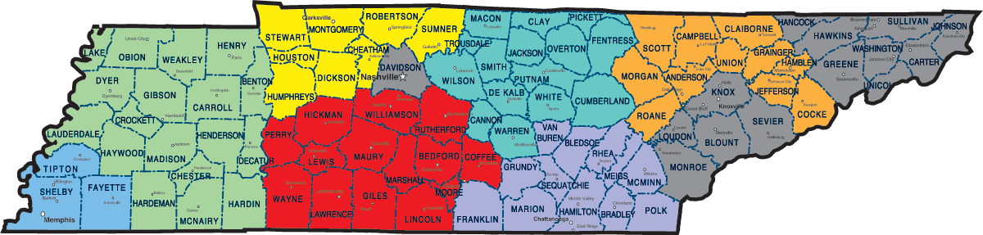

Mental Health Cooperative
(615) 726-0125
County: Davidson

Frontier Health
(877) 928-9062 (Upper East TN)

Helen Ross McNabb (East TN)
(865) 539-2409

Crisis Stabilization Units
(services can only be accessed by referral from Mobile Crisis Services, numbers provided above, or if a client goes to Walk-In Centers for assessment by Mobile Crisis)

Frontier Health – Johnson City, TN
877-928-9062

McNabb Center – Knoxville, TN
865-541-6958

McNabb Center- Morristown, TN
423-273-5599

Volunteer Behavior Health- Cookeville, TN
800-704-2651

Volunteer Behavior Health – Chattanooga, TN
800-704-2651

Mental Health Cooperative – Nashville, TN
615-726-0125

Pathways of Tennessee – Jackson, TN
731-541-8330

Alliance Healthcare Services – Memphis, TN
901-577-9400

