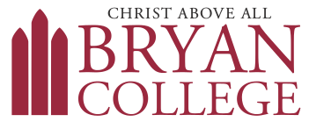
Counseling Services
721 Bryan Drive, Dayton, TN 37321
423.775.7513
Scope of Practice for Bryan College Counseling Services
As a college mental health service, the Bryan College Counseling Center is equipped to meet a range of unique needs presented by college students. Our professionals are committed to providing short-term quality care to degree-seeking residential and commuter undergraduate students and residential or local graduate students (We do not provide distance counseling at this time). Our staff deeply cares about the well-being of Bryan College students and has a strong emphasis on soul care. All students are welcome to walk into our offices to discuss their concerns with a counseling services staff member.
Bryan College Counseling Services provides a wide-range of therapeutic interventions for Bryan students. When a student’s needs require a more intensive, long-term level of care, we partner with the student to refer them to another mental health professional within the community.
Situations that may require a transition of care include:
- A need, or request, to be seen more than once a week for individual therapy.
- A need, or request, for uninterrupted individual services from semester to semester.
- A need, or request, for treatment modality not provided by our staff
- A need, or request, to be seen differently than what is clinically recommended.
- Presence of one or more of the following, such that the best treatment would be an intensive outpatient program (IOP) or higher level of care:
  - Alcohol and Other Drug Addiction
  - Eating disorders
  - Chronic thoughts and/or attempts of self-injury and/or suicide
- Request for:
  - Psychological testing or evaluations to attain ADA accommodations
  - Documentation for an emotional support animal

